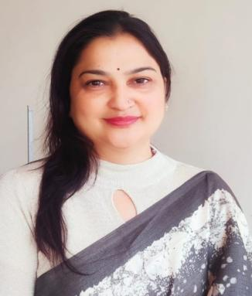 | Joint Secratary  Dr. Seema Sharma  Affiliation:  Assistant Professor, Department of Sociology S.D. Govt. College Beawar, MDS University Ajmer, Rajasthan- 305901.  Email: Seemasharmachauhan@gmail.com  Mobile: 91-9530253292

Dr. Seema sharma is an Assistant Professor in the Department of Sociology, S.D. Govt. College Beawar, MDS University Ajmer. In addition to educational services, she also served in the Social justice and Empowerment Department on the post of Assistant Director, Ajmer. She has dedicated 19 years of her life providing educational and administrative services in various government and private colleges of Rajasthan. She has written and edited two international level books and published 12 research papers in various reputed National and international journals. She has also been credited for organizing one international seminar and two international webinars.
Her area of specialization is Sociology of Gender, Medical Sociology, Sociology of Human Rights, and Sociological Studies of Prisons and Prisoners.
She has been an active participant as a life member in Indian Sociological Society (ISS), North West Indian Sociological Association (NWISA), Rajasthan Sociological Association (RSA), Social Science and Humanities Association (SSHA), Inspira Research Association (IRA), Sociological Society of Himachal Pradesh(SSHP), Society of Criminology, Victimology and Penology(SCVP).
At present she holds the position of Joint Secretary of Rajasthan Sociological Association (RSA) and Treasurer of Society of Criminology, Victimology and Penology (SCVP) and Secretary of NGO (Shree Deendayal sharma memorial shikshan anusandhan avam seva sansthan).

